**Thermography**

Thermography or Digital Infrared Thermal Imaging (DITI) is a screening tool for physiologic cellular health. It’s a non-invasive, radiation-free test that uses infrared imaging to perform a full body scan. It is most commonly used for Breast Cancer screenings where the equipment has an FDA 510k clearance for possible early detection but ideally prevention of cancer and other diseases.  The scan detects physiological changes in the body that are a response to disease or pathology, such as abnormal vascular activity and inflammation. By identifying hot spots or cold spots in the body you may be able to take steps, either through further diagnostic testing or changes in diet and lifestyle, to heal your body and eliminate inflammation.

Thermography produces an infrared image that shows the patterns of heat and blood flow near the surface of the body.  This is very different than other modalities such as Mammography, MRI, and ultrasounds that are useful for anatomical or structural analysis. Those tests look at what’s happening in the body that can be seen such as a cyst or a tumor. Thermography looks at the heat discrepancies in your body.

Thermography may detect disease years before it manifests in symptoms or sever health problems in some cases. You can receive a breast only scan, a health profile, or full body imaging. Early detection saves lives! Don’t delay, see if there’s room for improvement in your health today. Our technicians are certified through the Professional Academy of Clinical Thermology (PACT). Call us to schedule your screening! (877) 315-7226 Ext. 447

**It is well known that early detection is the best defense against breast cancer and that, if treated in the earliest stages, a 95% cure rate is achieved. The “cure” is early detection.**

**Can you tell which woman has a developing breast cancer that can be detected EARLY by thermography and may be missed by anatomical tests for up to 10 years?**  


**Chiropractic Care**

Child care pre-treatments on the left and post treatments on the right.

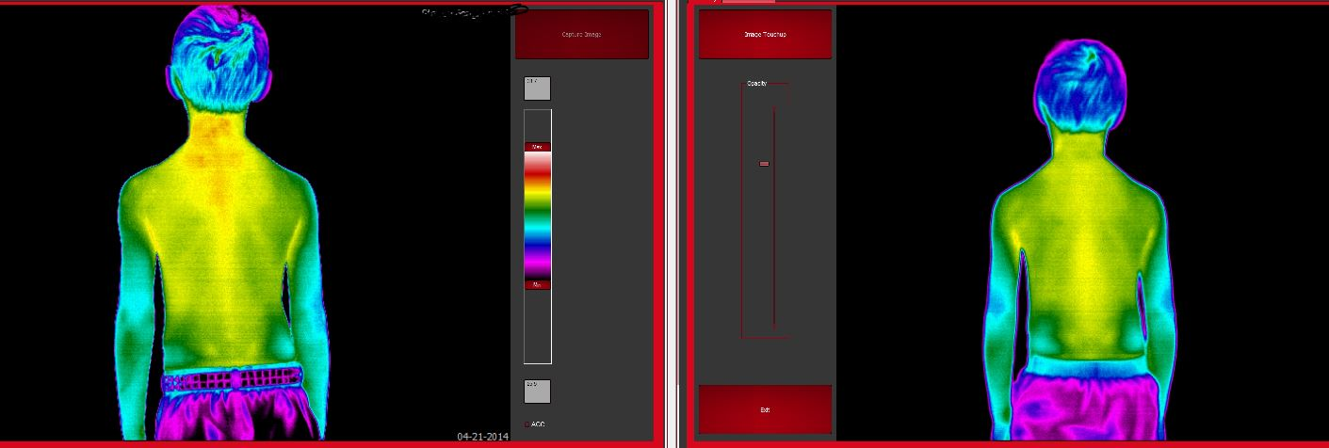

Patient treatments starting in March 2014 – June 2014. See the inflammation in the upper thoracic region.

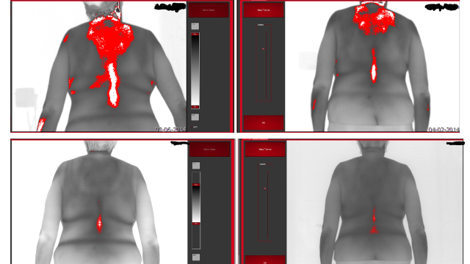

In addition to breast cancer screening and monitoring treatments, thermography can be utilized for analysis of other conditions including the following:

|  |  |  |  |
| --- | --- | --- | --- |
| Carotid Artery Disease | Vascular inflammation | Arthritis | Neurological disorders |
| TMJ | Carpel Tunnel syndrome | Spinal disc disease | Bursitis |
| Fibromyalgia | Sinus inflammation/Disease | Nerve impingement | Mouth disease |
| Thyroid | Hormonal Evaluation | Abdominal Inflammation | Vein Thrombosis |

Incorporate an exercise program or participate in a detox program with the guidance of your healthcare professional. You can see the positive changes thermographically in the images below. Look how many of these heat signatures decreased! Hot spots on the breast can indicate early signs of cancer, hormonal imbalances or too much toxicity in the body. Find a health exercise program that works for you, improve your diet and detox your body to achieve optional wellness!

Below are images in rainbow pallet to best see heat in color. Red, orange and yellow are the warmer colors and green blue and purple are the cooler colors. Black is the coldest. See how the yellow vascular patterns decreased from April 2011 to May 2012 on the breasts? Also the inflammation around the mouth decreased substantially!

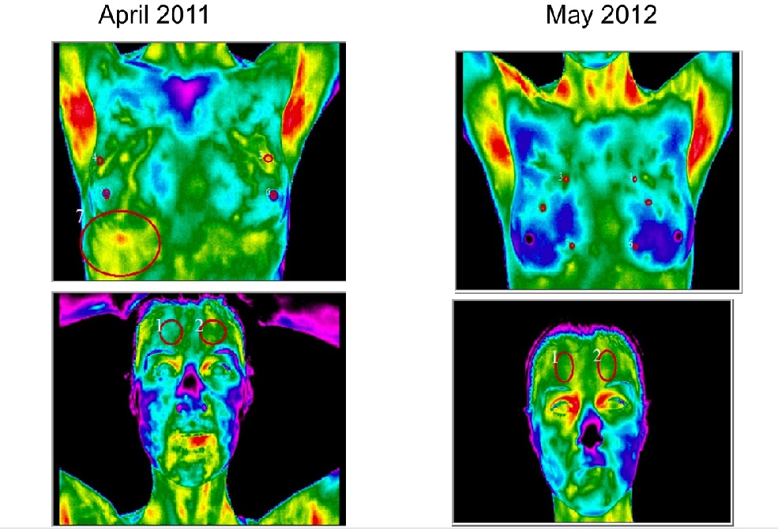

This is the same patient below only the images are in a reverse grayscale palette where you can best see vascular patterns. Notice how the vascular patterns decreased in the breast area after exercise and detox programs were completed!

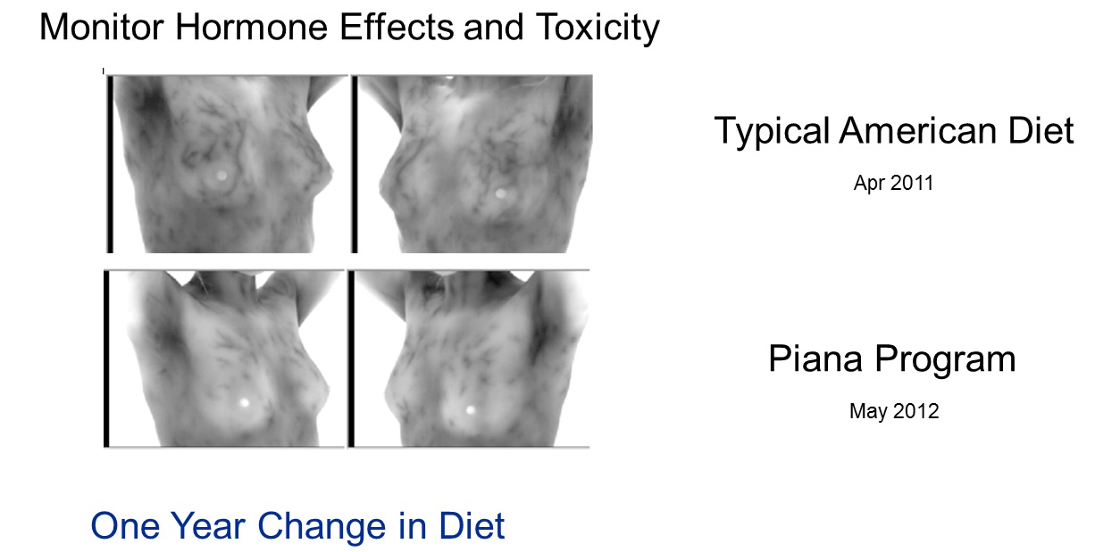

Detox program

April 2014



Dec. 2014 Look how the yellow vascular patterns decreased!



Oct. 2012



July 2013, after a detox and exercise program patient loss 20 lbs and decreased her vascular patterns in her breasts. Hot vascular patterns can represent cancer, fibrocystic syndrome or toxicity in the body.



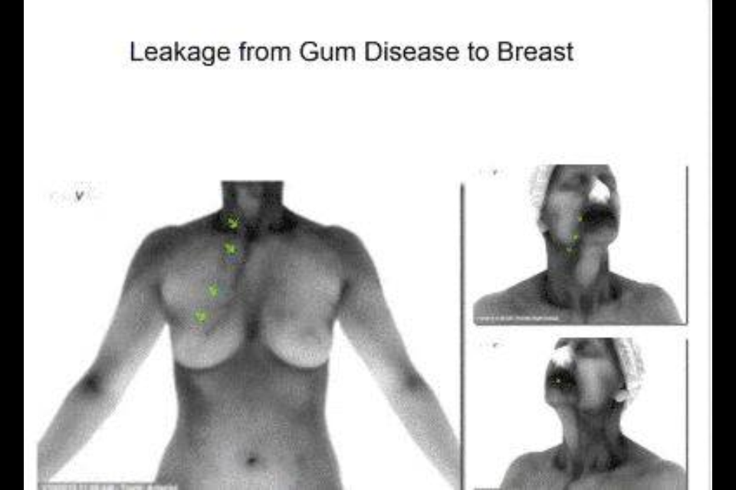

Patient needed her thermography scan to show her she has to take care of a known tooth infection.

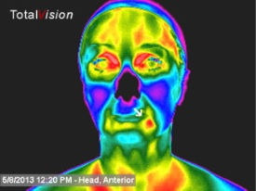

For more information about Medical Thermogaphy check out the link below and research all the sites on this link.

<https://www.flowwell.org/thermography>

To schedule a screening click this link <https://app.acuityscheduling.com/schedule.php?owner=17724731>

or call (877) 315-7226 Ext. 447.

Patient completed 10 sessions of Lymphatic Full Body treatments between scans. Look at the incredible improvements!

10/8/15 Before:

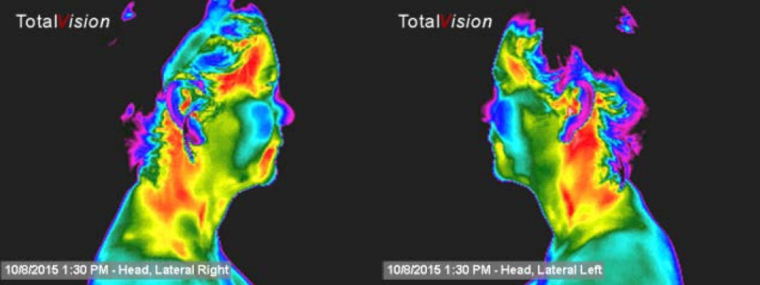

1/14/16 After:

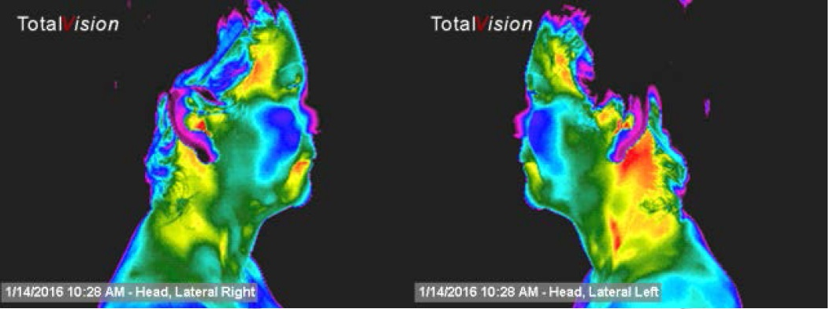

Look how much the red or the hotter temperatures have decreased as well as the yellow temps! It’s working!

10/8/15 Before:

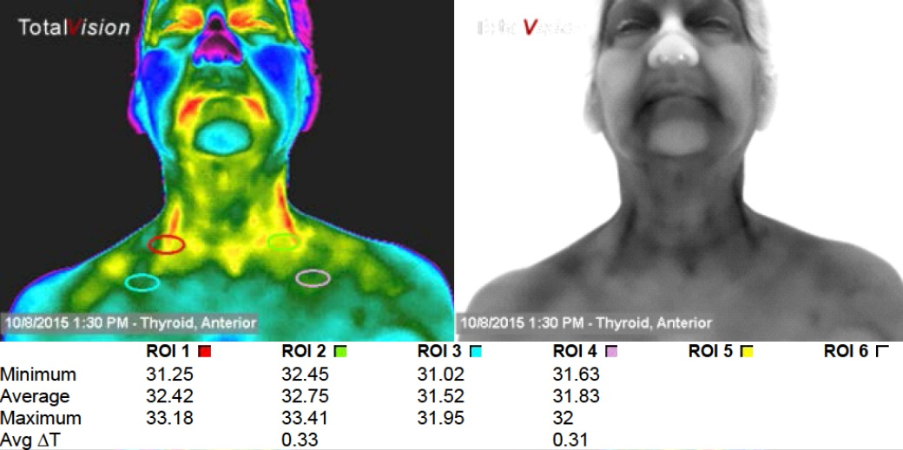

1/14/16 After:

